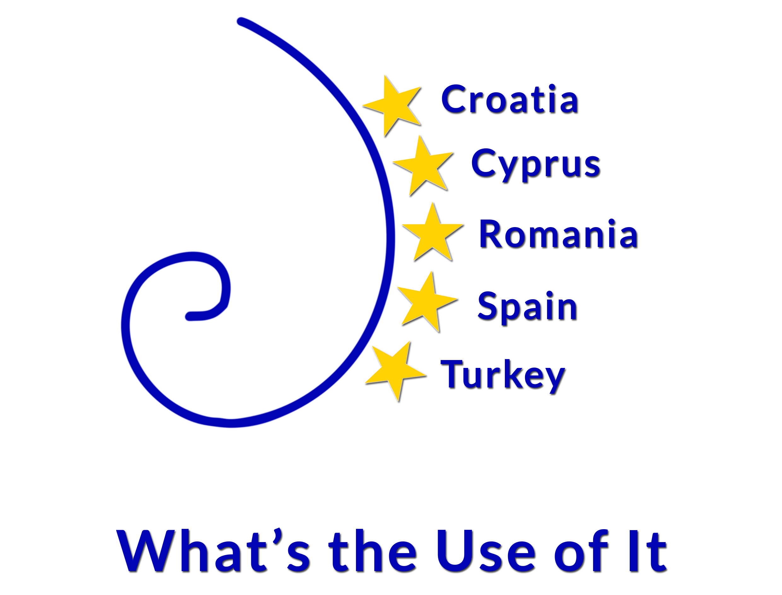

Gimnazija Metković, Croatia
8 - 12 December 2014

GIMNAZIJA METKOVIĆ, Croatia
AGENDA
7 December 2014 (Sunday)

arrival of guests and hotel accommodation;

8 December 2014 (Monday)

10:00 to 10:30 a.m. Opening ceremony: the Principal's welcome speech (at School
Library)
10:30 to 11:00 a.m. Mutual presentations and getting to know each other
11:00 to 12:00 a.m. PowerPoint presentation of the Dubrovnik-Neretva County, City of
Metković and Metković Grammar School
12:00 to 15:00 p.m. Visit to the Municipality and the Mayor, short city sightseeing tour
15:00 to 18:00 p.m. Introduction to theTwinSpace, Erasmus + requirements, expenses,
obligations towards the National Agencies (at School )
Dinner, free time: socializing

9 December 2014 (Tuesday)

9:00 to 12:00 a.m. Presentation of the mathematical curriculum of each partner country
(at School)
12:00 to 15:00 p.m. Outdoor activities: leaving for Vid to visit the Archeological Museum
and its surroundings, photo safari in traditional boats
15:00 to 18:00 p.m. Comparison of mathematical curricula and selection of topics for
the work within the project (at School)
Dinner, free time: socializing

10 December 2014 (Wednesday)

9:00 to 12:00 a.m. Work on topics; discussion on the way of carrying out the project;
optional visits to domestic teaching classes (at School)
12:00 to 15:00 p.m. Outdoor activities: a visit to the Cave, the Museum of Natural History,
Predolac Hill
15:00 to 18:00 p.m. Continuation of work ( at School)
Dinner, free time: socializing

11 December 2014 (Thursday)

8:00 to 18:00 p.m. Outdoor activities: one-day trip to Dubrovnik

12 December 2014 (Friday)

9:00 - Further work (at School): Evaluation lists, Certificates
Farwell party; Leaving Croatia

On December 9, 2014 nineteen teachers of Mathematics, English language, Information Technology and Electrical Engineering arrived from Romania, Cyprus, Turkey and Spain to Metković, Croatia to visit the Grammar School Metković in order to carry out a series of working meetings on the project “What’s the Use of It” within Erasmus +
It is a transnational project which deals with both students mobility and sharing experience in improving the teaching skills in Maths. The main project team is the group of teachers of Mathematics led by Mrs Ljiljana Jeličić.
The guests were welcomed both by the school principal, Jozo Jurkovic at the opening ceremony in the school and Miss Katarina Ujdur, Deputy Mayor in the Town municipality.

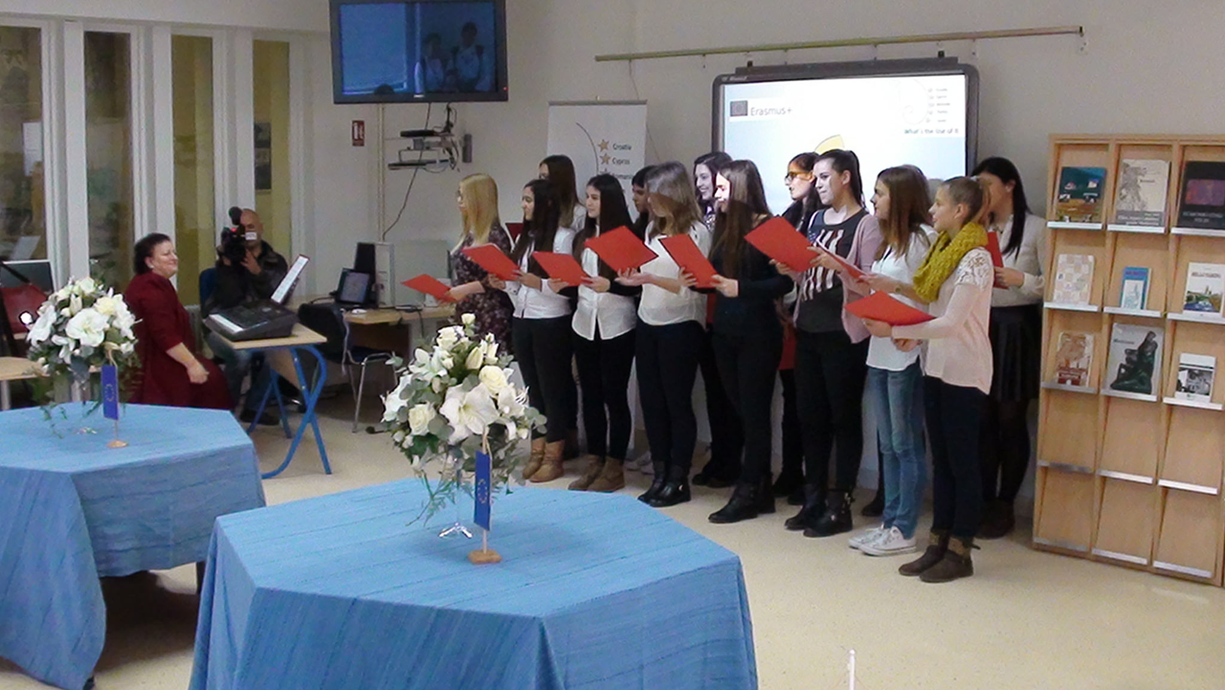
School choir

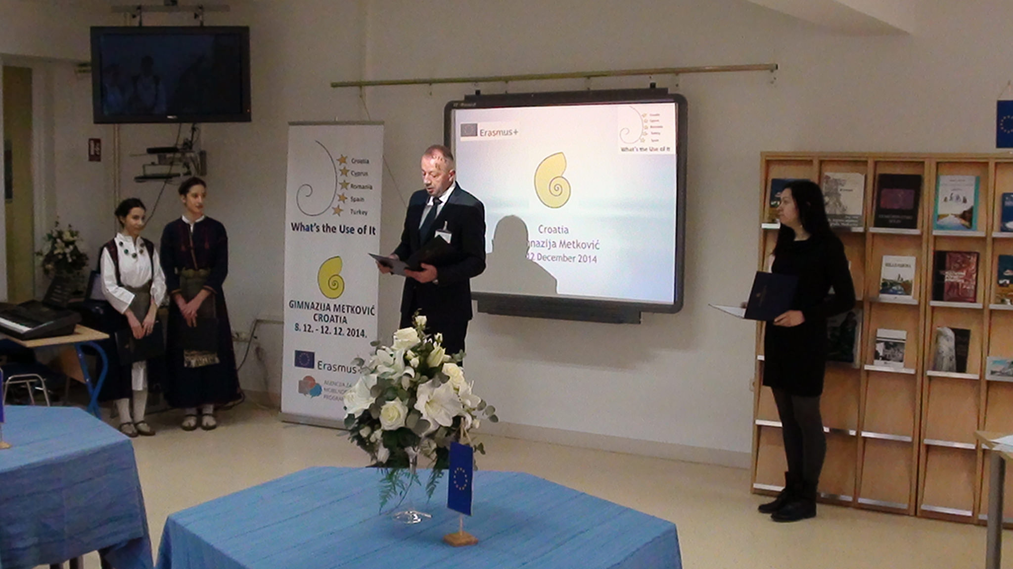
The school principal

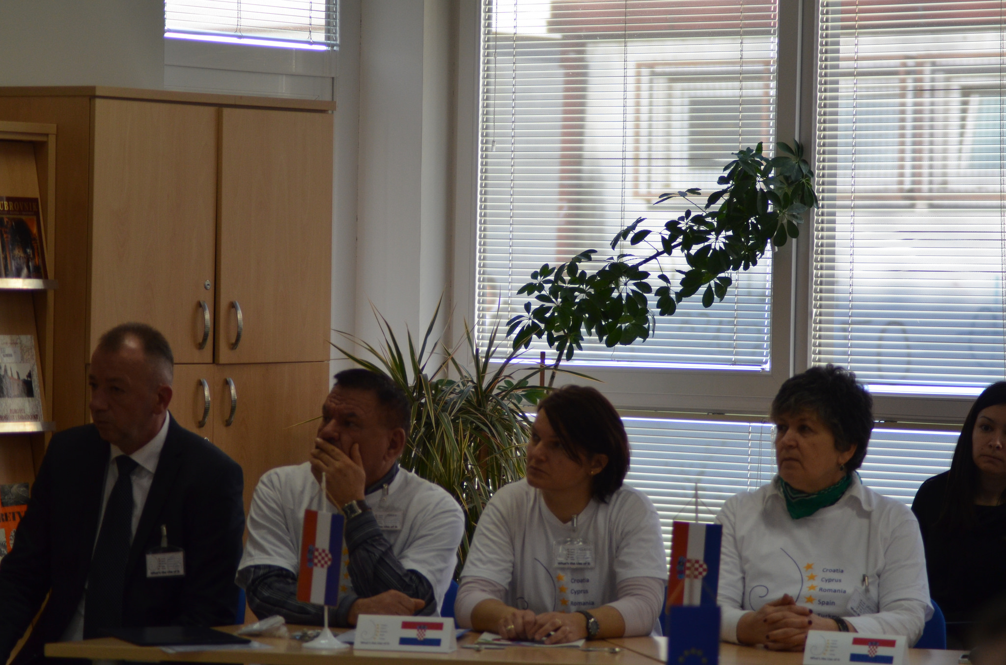
The Croatian team

Each team was supposed to make a presentation on their school, town, country with the idea of breaking ice and getting to know each other better.

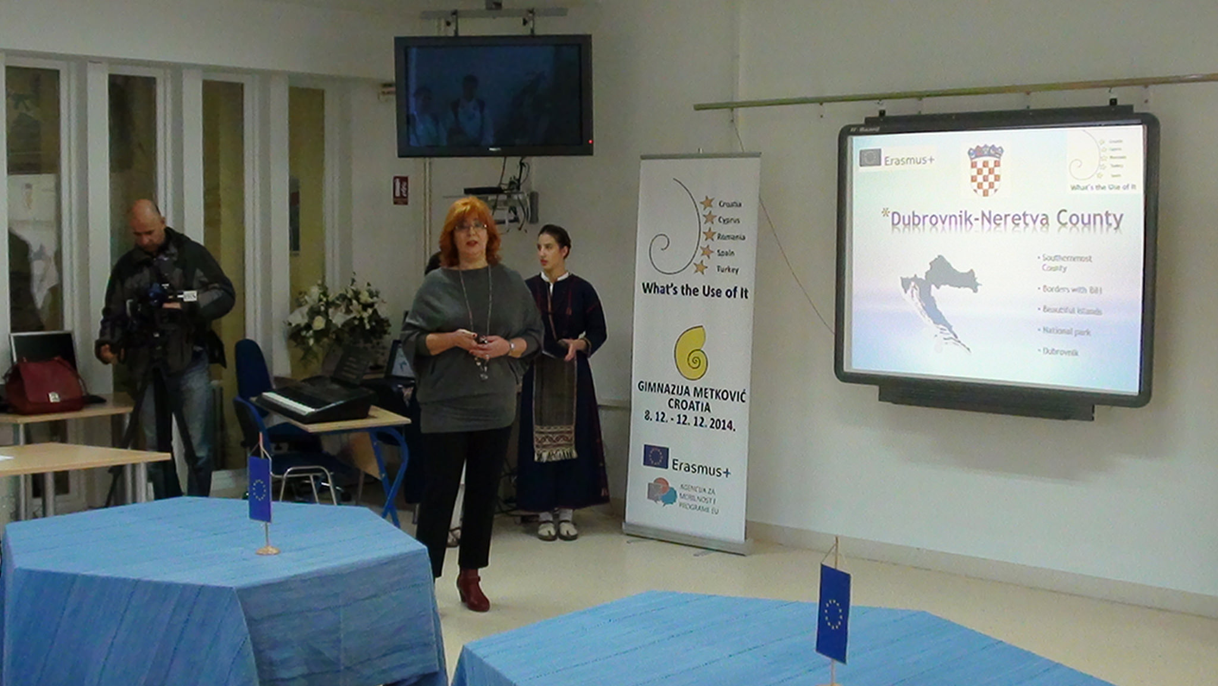
Croatian presentation

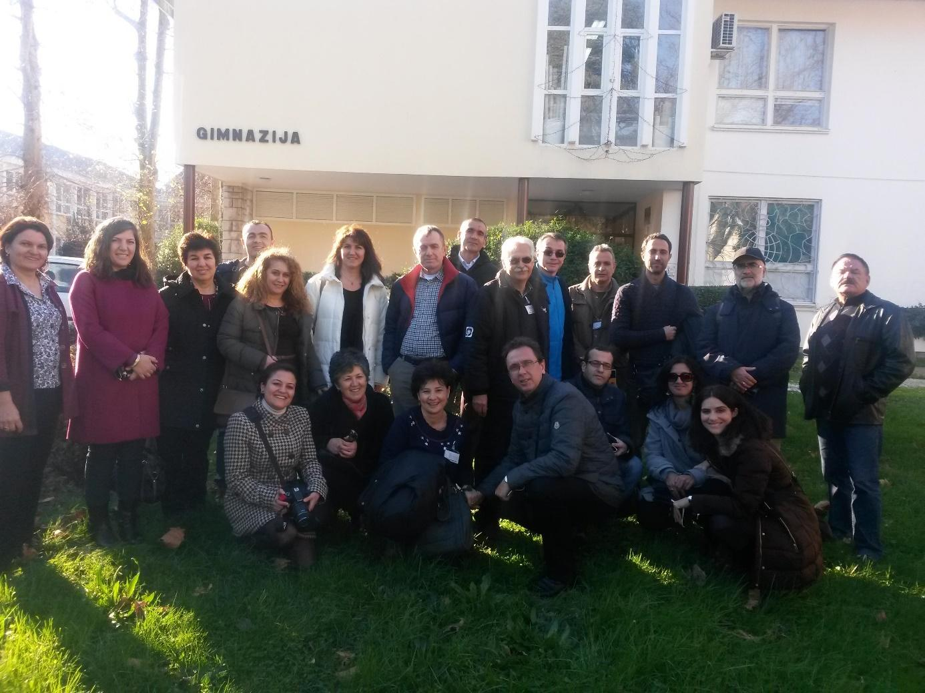
All participants in front of the school
In addition to the working sessions, the guests had the opportunity to get to know the town, visit the ancient Archeological Narona Museum, take a ride in the typical boats on the Neretva. They were also taken to the nearby towns of Ston and Dubrovnik, the Pearl of the Adriatic.
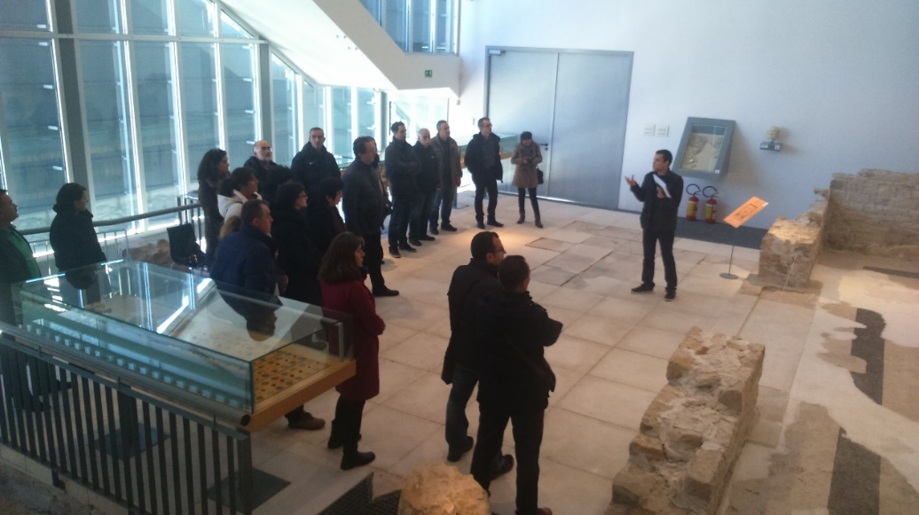
Archeological Narona Museum
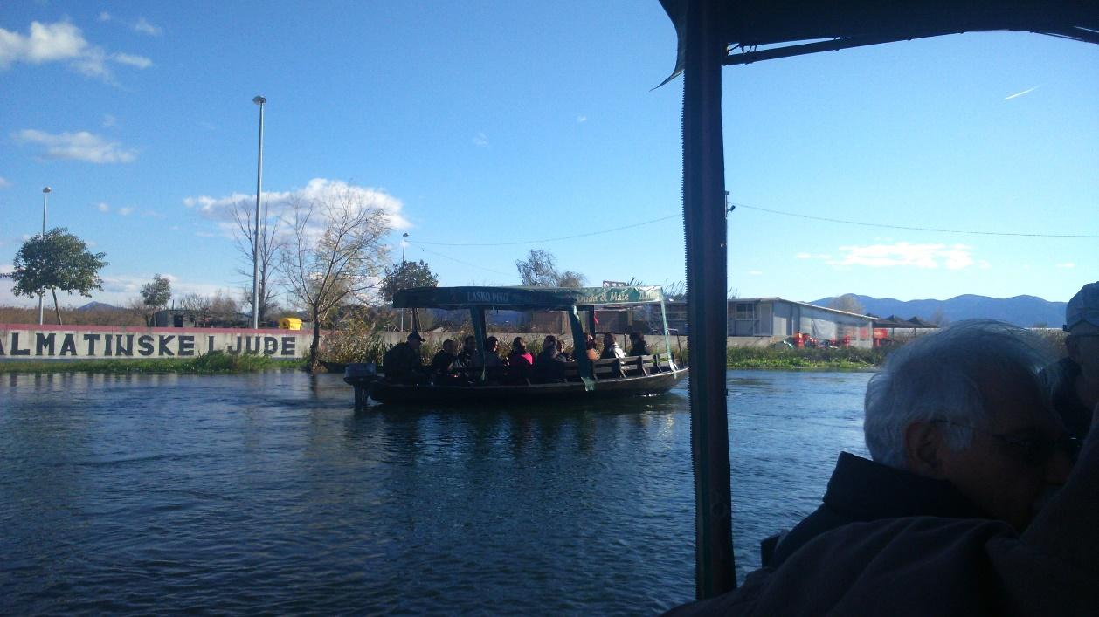
Photo safari

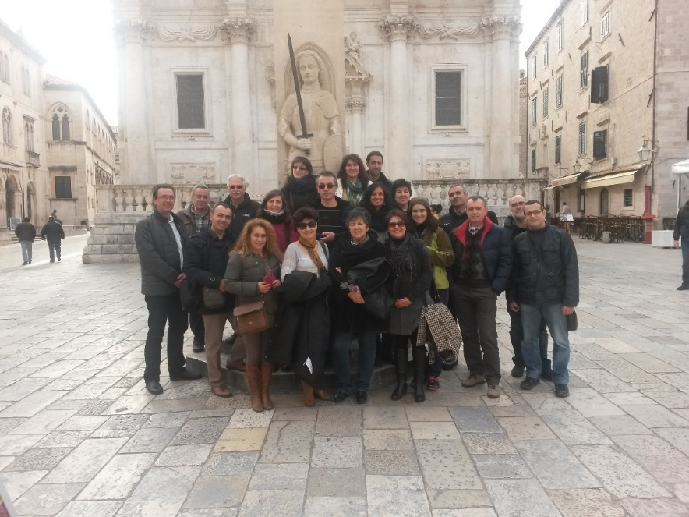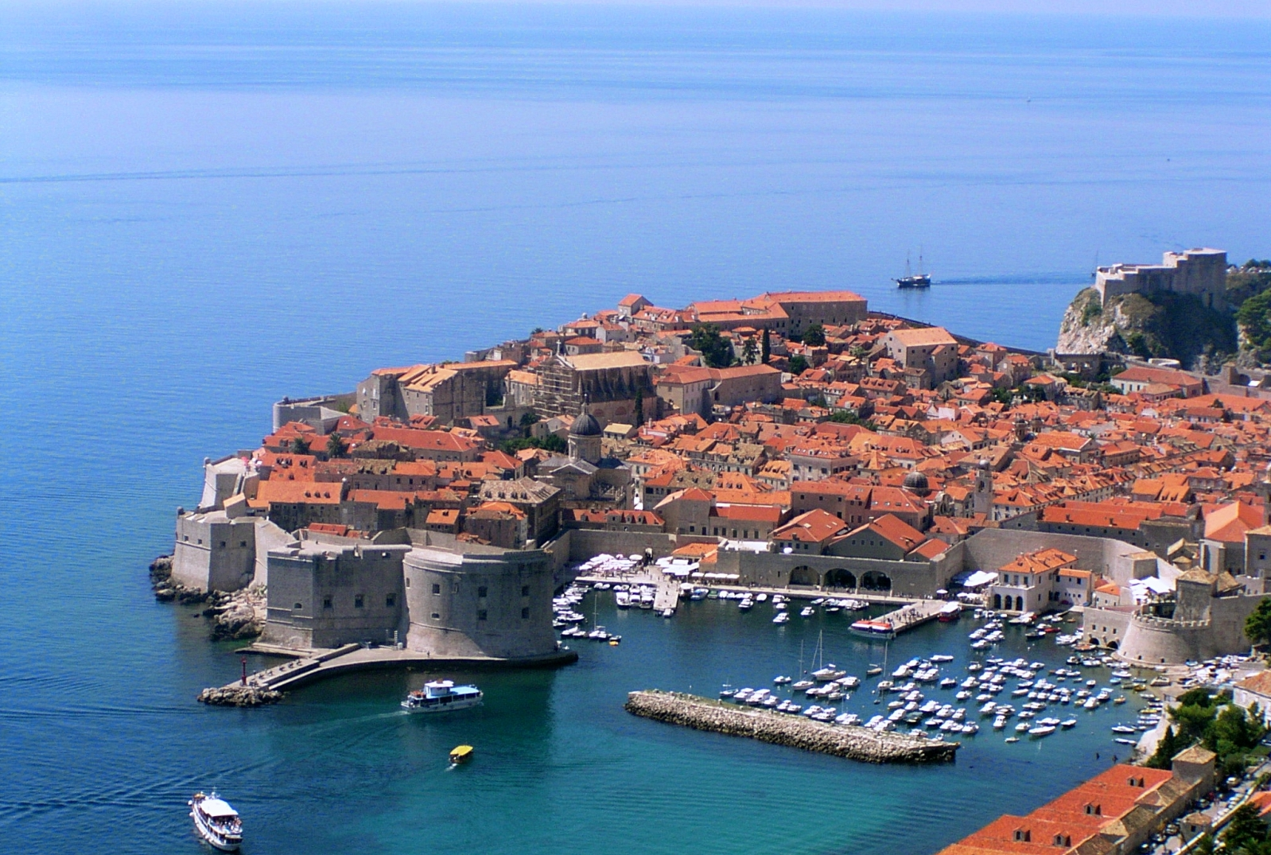
From Dubrovnik
To get to know what the school program is like, a few guests were present to some classes while our teaches were teaching students in Mathematics, English language, Arts and the Croatian language. It could be a good practice because the guests had an an excellent experience!
Several undergraduates spontaneously came up with an idea to make a short interview with the foreign teachers in English for their project by Goethe Institute Schülerzeitung Nasch-PASCH . You can see the video on the school website.
The official part of the Croatian meeting finished with filling in the Evaluation Form, the Report of which is enclosed below.

Next meeting will be held in Cyprus on 24 February, 2015

R E P O R T

On the results from Evaluation Forms

On 11 December 2014 all the members were asked to fill in the Evaluation Forms. This report examines: a) Course design, b) Facilities/Arrangements and c) Comments/Suggestions and Recommendations.

- Course design: 87% of surveyed teachers strongly agree that the course was well organized despite the fact that a few think that it was not clear what they were supposed to do.
- Facilities/arrangements: everybody, with no exceptions, agrees that accommodation, food, meeting rooms and premises, as well as school administration, together with host teachers and students were not just satisfactory, but absolutely perfect.
- Comments/recommendations: 60 % of the teachers agree that the workshop can be graded as excellent and the rest as good. Apart from their expressing gratitude for all the hospitality and generosity, students' behaviour during the sessions, perfect experience from class visits, after-school activities/ trips, there are a few suggestions:
- About statistics teaching
- To be well informed in advance
- Tasks must be discussed in details

Metković, 20 December 2014

PARTICIPANTS IN THE PROJECT

Country | School | Name
Croatia | Gimnazija Metković | Ljiljana Jeličić
Croatia | Gimnazija Metković | Ljubica Jerković
Croatia | Gimnazija Metković | Mirko Crnčević
Croatia | Gimnazija Metković | Živka Franković
Croatia | Gimnazija Metković | Marinko Zubac
Cyprus | B Techniki Sxoli Lemesou | Venediktos Hadjisavvas
Cyprus | B Techniki Sxoli Lemesou | Costas Schinis
Romania | National College „Gheorghe Vranceanu“ | Bianca Balaban
Romania | National College „Gheorghe Vranceanu“ | Gabriel Andrei
Romania | National College „Gheorghe Vranceanu“ | Cristian-Ovidiu Merticaru
Romania | National College „Gheorghe Vranceanu“ | Cristina-Elena Andrei
Spain | IES Infanta Elena | Catalina Ayala Molina
Spain | IES Infanta Elena | Miguel Angel Garcia Lopez
Spain | IES Infanta Elena | Santiago Gonzalez Benitez
Spain | IES Infanta Elena | Marisa Martinez Molina
Spain | IES Infanta Elena | Antonio Lozano Monreal
Türkiye | Ankara Fen Lisesi | Nihat Köse
Türkiye | Ankara Fen Lisesi | Eray Donmez Yildirim
Türkiye | Ankara Fen Lisesi | Ikbal Kilic
Türkiye | Ankara Fen Lisesi | Hacer Sarikaya
Türkiye | Ankara Fen Lisesi | Recep Tez
Türkiye | Tavas Özay Gönlum High School | Hasan Oguzhan
Türkiye | Tavas Özay Gönlum High School | Nese Özdenir
Türkiye | Tavas Özay Gönlum High School | Aysun Kaban

